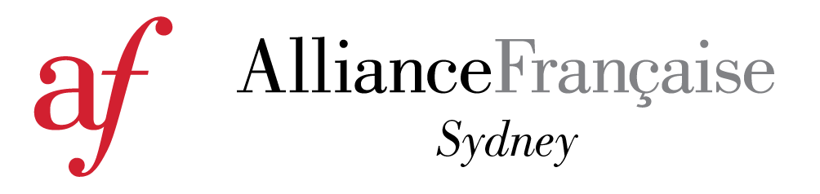

BENEFITS EXPLAINED...
A free and unlimited access to our e-library, the Culturethèque
Our new French multimedia e-library provides our members with a 24/7 access to 400 magazines, 1,000 books, 200 comics, 450 videos, and 370 learning materials. Culturethèque is available throughout Australia.
More information HERE.
Access to our Media Centre
Members are entitled to borrow DVDs, CDs and books, all free of charge. Books may be borrowed for a fortnight, DVDs and CDs for one week. Borrowing from the media centre is reserved for members of the Alliance Francaise only.
15% off on our Essentials Workshops
Book a 3-hour workshop to help you brush-up on each levels' key aspects.
Workshops available for A1 (beginners), A2 (elementary) and B1 (intermediate) levels. All materials provided by the teacher
More information HERE
Free activities
- 13/14: Take part in lively discussions on current issues
- Book Club: Discuss French literature with us monthly
- Giveaways: Win CDs, DVDs, movie and event tickets
Discounts to all Alliance Française functions
Members obtain discounted ticket prices for most of our annual events. These popular events attract French and non-French speakers, students, friends and cultural partners. There are many other events during the year: art exhibitions, conferences, film nights, wine and cheese tastings and many more.
Discounts to the Alliance Française French Film Festival
Members can purchase discounted ticket prices to all films of the Alliance Française French Film Festival ($5 off) as well as access to members only screenings. The Festival is the biggest event on the Alliance Française calendar, held over a 3 week period in Sydney, and a 5 week period nationally. www.affrenchfilmfestival.org
Discounts with Alliance Française partners
Members receive special offers from Alliance Française partners including Abbey’s Bookshop, Art Gallery New South Wales, Canal Sat, Sydney Symphony Orchestra and more.
Special offers and give aways for members and students to French events organized by cultural institutions in Sydney
Art Gallery New South Wales, Australian Brandeburg Orchestra, Australian Chamber Orchestra, Balmain Symfonia, Camerata Antipodes, Carriage Works, City Recital Hall, Foundry 616, Jewish French Film Festival, Les Misérables, Museum of Sydney, Open Air Cinemas, Opera Australia, Palace Cinemas, Salut! Baroque, So Frenchy So Chic, State Library of New South Wales, Sydney Film Festival, Sydney Dance Company, Sydney Festival, Sydney Opera House, Sydney Philarmonia Choirs, Sydney Symphony Orchestra, Taste of Sydney, The Basement.
Discount on Conference Room Hire
Top floor of the Alliance Francaise's building
PRICES
Individual: $80
Family: $100
Concession: $60. For Concession Card holders only.
School: $100 Please contact school-activities@afsydney.com.au for more information
Corporate: Please contact enquiries@afsydney.com.au for more information

