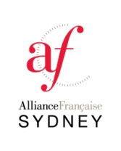

FUNCTION ROOM BOOKING FORM
Company name:
Contact: Contact person on event day:
Position: Position:
Direct contact phone number: Direct contact phone number:
Postal Address:
Email:
BOOKING DETAILS
Brief description of the event: Number of people expected:
Date: Total number of hours required:
Access time:
Departing time:

Facilities required:
- Projector, Wifi, 2 microphones (included in hiring cost)
Catering available from Bonjour Café (quote on demand)
Small stage/podium
Other:

Chairs/Tables set up:
U shape Classroom set up Rows
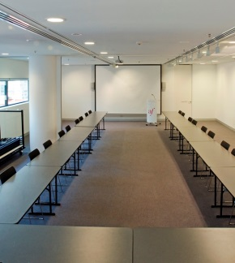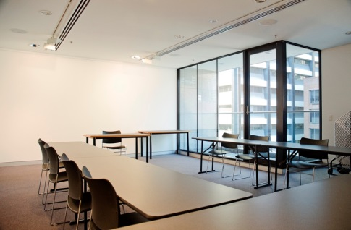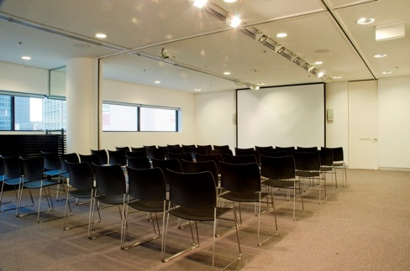
FEES AND CONDITIONS
- The annual corporate membership cost is 480 AUD and includes the first use of the room for free.
 | Non member | Corporate member
First 2 hours | 400 AUD | 200 AUD
Following hours | 100 AUD | 50 AUD
Whole day booking 9am to 5pm | 800 AUD | 400 AUD

- Payment can be made over the phone or by Bank transfer
Bank ANZ
BSB 012055
Account 527632688
Name Alliance Francaise de Sydney
- THE BOOKING WILL BE CONFIRMED ONCE PAYMENT HAS BEEN RECEIVED
- Please note that the Alliance Francaise is not linked to your company nor event, therefore we request that you do not advertise your event using the “Alliance Francaise” name.

I acknowledge that I have read and accepted these conditions

Return to: enquiries@afsydney.com.au

OFFICE USE ONLY:

Request processed by: | Date received:
Quote/Invoice sent: | Payment received:
Additional comments:

www.afsydney.com.au | 02 9292 5700

